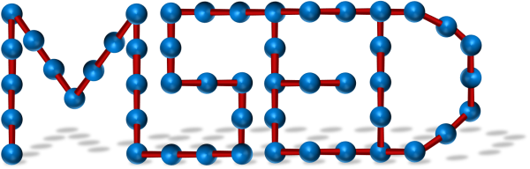
MACROMOLECULAR SCIENCE and The Chemical
ENGINEERING DIVISION Institute of
Canada

GRADUATE AWARD IN POLYMER CHEMISTRY

The Macromolecular Science and Engineering Division of the Chemical Institute of Canada announces its graduate award in polymer chemistry. The award is open to all graduate students who are currently pursuing either a master’s or doctorate degree in the area of polymer science or polymer engineering at a Canadian university. Students having graduated in January 2025 or afterwards will also be considered for the award.

The complete award application submitted by the applicant must include:
1) The application form.
2) A concise C.V., including a complete list of publications, conference presentations, patents, and other contributions arising from polymer related graduate research at the Canadian institution.
3) A detailed research report (no more than 4 pages) highlighting the applicant’s major scientific contributions to the field of study. The hypotheses and objectives of both completed and ongoing research should be clearly stated. The student’s contributions to any publications should also be briefly stated.
4) A letter of recommendation from the research supervisor(s), clearly stating the strengths of the applicant. (The support letter may be sent separately by the supervisor.)

Applications must be sent as a single PDF file by e-mail containing the required information in the order stated above to the award coordinator: The selection criteria is scientific merit, creativity, originality, and contributions to the relevant field.

Award Coordinator: Dr. Chantal Paquet
Research Officer
National Research Council of Canada
E-mail: Chantal.Paquet@nrc-cnrc.gc.ca

APPLICATION DEADLINE: November 2nd, 2026

MACROMOLECULAR SCIENCE and ENGINEERING DIVISION

GRADUATE AWARD IN POLYMER CHEMISTRY

APPLICATION FORM

Applicant’s Name
Institution:
Department:
Program: | Ph.D. M.Sc.
Title of Thesis:
Thesis Supervisor:
Program Entry Date: |  | Expected Graduation Date:
Applicant’s Signature |  |  | Date
Supervisor’s Signature* |  |  | Date
(*Note: the signature confirms the supervisor will provide a letter of recommendation for the applicant.)
The complete application consists of: 1) application form, 2) C.V., 3) concise research report, and 4) supervisor’s recommendation letter. The complete application must be sent to the award coordinator as a single PDF file by the deadline. The application may be submitted in either English or French.

